MySQL Show View

MySQL Show View –  using SHOW FULL TABLES statement

To show all [views](https://www.mysqltutorial.org/mysql-views-tutorial.aspx) in the current database, you use the [SHOW FULL TABLES](https://www.mysqltutorial.org/mysql-show-tables/) statement as follows:

**SHOW** **FULL** **TABLES**

**WHERE** table_type = 'VIEW';

Code language: SQL (Structured Query Language) (sql)

Because the SHOW FULL TABLES statement returns both tables and views, you need to add a [WHERE](https://www.mysqltutorial.org/mysql-where/) clause to get the views only.

If you want to show all views from another database, you use this syntax:

**SHOW** **FULL** **TABLES**

[{**FROM** | **IN** } database_name]

**WHERE** table_type = 'VIEW';

Code language: SQL (Structured Query Language) (sql)

In this statement, you specify the name of the database from which you want to show the views after the FROM or IN clause.

The following example shows all views from the sys database:

**SHOW** **FULL** **TABLES** **IN** **sys**

**WHERE** table_type='VIEW';

Code language: SQL (Structured Query Language) (sql)

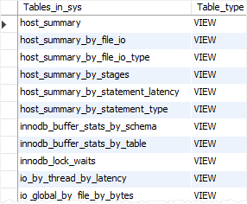

If you want to get a view based on a pattern, you can use the LIKE clause as follows:

**SHOW** **FULL** **TABLES**

[{**FROM** | **IN** } database_name]

**LIKE** pattern;

Code language: SQL (Structured Query Language) (sql)

This example uses the LIKE clause to find all views from the sys database, whose names start with the waits:

**SHOW** **FULL** **TABLES**

**FROM** **sys**

**LIKE** 'waits%';

Code language: SQL (Structured Query Language) (sql)

Here is the output:

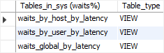

Note that if you have no privileges for a view, it will not show up in the output of the SHOW TABLES statement.

MySQL Show View –  using INFORMATION_SCHEMA database

The INFORMATION_SCHEMA database provides access to MySQL database metadata such as names of databases, tables, data types of columns, or privileges.

The INFORMATION_SCHEMA is sometimes referred to as a database dictionary or system catalog.

To show the views of a database, you use the tables table from the INFORMATION_SCHEMA.

**SELECT** *

**FROM** information_schema.tables;

Code language: SQL (Structured Query Language) (sql)

Here is the partial output:

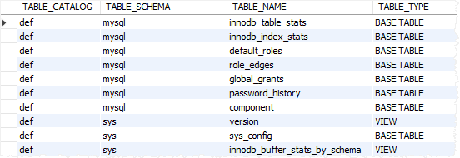

In this output, we are interested in three columns only table_schema, table_name, table_type:

* The table_schema column stores the schema or database of the view (or table).
* The table_name column stores the name of the view (or table).
* The table_type column stores the type of tables: BASE TABLE for a table, VIEW for a view, or SYSTEM VIEW for an INFORMATION_SCHEMA table.

This query returns all views from the classicmodels database:

**SELECT**

table_name view_name

**FROM**

information_schema.tables

**WHERE**

table_type = 'VIEW' **AND**

table_schema = 'classicmodels';

Code language: SQL (Structured Query Language) (sql)

To find a specific view based on a pattern, you use the table_name column. For example, this query finds all views whose names start with customer:

**SELECT**

table_name view_name

**FROM**

information_schema.tables

**WHERE**

table_type = 'VIEW' **AND**

table_schema = 'classicmodels' **AND**

table_name **LIKE** 'customer%';

Code language: SQL (Structured Query Language) (sql)

